**LAB SET 9**

Write a program to fill a 3D cube with a set of six colors for its six faces with the Z-

buffer hidden surface removal algorithm. Allow the user to view all faces of the cube

with rotation.

//Lab Set 9 Program

//Akarsh Singh

#include <GL/glut.h>

double rotate_y=0;

double rotate_x=0;

void display()

{

// Clear screen and Z-buffer

glClear(GL_COLOR_BUFFER_BIT|GL_DEPTH_BUFFER_BIT);

// Reset transformations

glLoadIdentity();// Rotate when user changes rotate_x and rotate_y

glRotatef( rotate_x, 1.0, 0.0, 0.0 );

glRotatef( rotate_y, 0.0, 1.0, 0.0 );

//Multi-colored side - FRONT

glBegin(GL_POLYGON);

glColor3f( 1.0, 0.0, 0.0 );

glVertex3f( 0.5, -0.5, -0.5 ); // P1 is red

glColor3f( 0.0, 1.0, 0.0 );

glVertex3f( 0.5, 0.5, -0.5 ); // P2 is green

glColor3f( 0.0, 0.0, 1.0 );

glVertex3f( -0.5, 0.5, -0.5 ); // P3 is blue

glColor3f( 1.0, 0.0, 1.0 );

glVertex3f( -0.5, -0.5, -0.5 );// P4 is purple

glEnd();

// White side - BACK

glBegin(GL_POLYGON);

glColor3f( 1.0, 1.0, 1.0 );

glVertex3f( 0.5, -0.5, 0.5 );

glVertex3f( 0.5, 0.5, 0.5 );

glVertex3f( -0.5, 0.5, 0.5 );

glVertex3f( -0.5, -0.5, 0.5 );

glEnd();

// Purple side - RIGHT

glBegin(GL_POLYGON);

glColor3f( 1.0, 0.0, 1.0 );

glVertex3f( 0.5, -0.5, -0.5 );

glVertex3f( 0.5, 0.5, -0.5 );

glVertex3f( 0.5, 0.5, 0.5 );

glVertex3f( 0.5, -0.5, 0.5 );

glEnd();

// Green side - LEFT

glBegin(GL_POLYGON);

glColor3f( 0.0, 1.0, 0.0 );

glVertex3f( -0.5, -0.5, 0.5 );

glVertex3f( -0.5, 0.5, 0.5 );

glVertex3f( -0.5, 0.5, -0.5 );

glVertex3f( -0.5, -0.5, -0.5 );

glEnd();

// Blue side - TOP

glBegin(GL_POLYGON);

glColor3f( 0.0, 0.0, 1.0 );

glVertex3f( 0.5, 0.5, 0.5 );

glVertex3f( 0.5, 0.5, -0.5 );

glVertex3f( -0.5, 0.5, -0.5 );

glVertex3f( -0.5, 0.5, 0.5 );

glEnd();

// Red side - BOTTOM

glBegin(GL_POLYGON);

glColor3f( 1.0, 0.0, 0.0 );

glVertex3f( 0.5, -0.5, -0.5 );

glVertex3f( 0.5, -0.5, 0.5 );

glVertex3f( -0.5, -0.5, 0.5 );

glVertex3f( -0.5, -0.5, -0.5 );

glEnd();

glFlush();

glutSwapBuffers();

}

// specialKeys() Callback Function

void specialKeys( int key, int x, int y )

{

// Right arrow - increase rotation by 5 degree

if (key == GLUT_KEY_RIGHT)

rotate_y += 5;

// Left arrow - decrease rotation by 5 degree

else if (key == GLUT_KEY_LEFT)

rotate_y -= 5;

else if (key == GLUT_KEY_UP)

rotate_x += 5;

else if (key == GLUT_KEY_DOWN)

rotate_x -= 5;

// Request display update

glutPostRedisplay();

}

int main(int argc, char* argv[])

{

// Initialize GLUT and process user parameters

glutInit(&argc,argv);

// Request double buffered true color window with Z-buffer

glutInitDisplayMode(GLUT_DOUBLE | GLUT_RGB | GLUT_DEPTH);

// Create window

glutCreateWindow("Rotating Cube");

// Enable Z-buffer depth test

glEnable(GL_DEPTH_TEST);// Callback functions

glutDisplayFunc(display);

glutSpecialFunc(specialKeys);

// Pass control to GLUT for events

glutMainLoop();

return 0;

}

**OUTPUT**

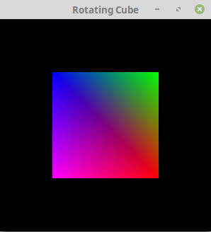 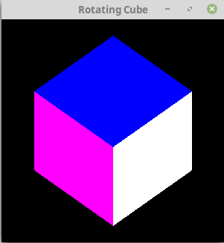

**Screenshot 1 Screenshot 2**

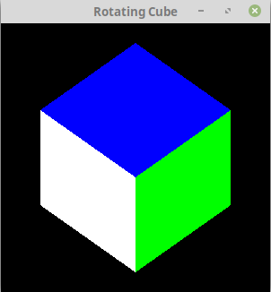 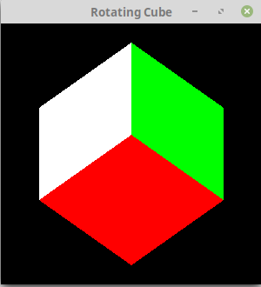

**Screenshot 3 Screenshot 4**